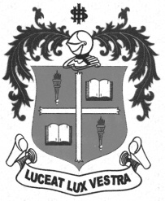
LOYOLA COLLEGE (AUTONOMOUS), CHENNAI – 600 034
M.A. DEGREE EXAMINATION - ENGLISH LITERATURE
FOURTH SEMESTER – APRIL 2011

EL 4812 - NOVEL AND SHORT STORIES FROM 1900

Date : 07-04-2011 Dept. No. Max. : 100 Marks

Time : 9:00 - 12:00
Section A

- Answer any Five of the following in about 200 words each: 5x8=40

- Atticus is a man who wants to look at things from others’ point of view – Discuss:
- Estimate the character of John in Go Tell It on the Mountain.
- Consider Jason as a hardcore materialist.
- Evaluate Ms. Eckhart as a music teacher in June Recital.
- Comment on the characterization of the novel The Razor’s Edge.
- Write a note on the central symbol of the church in James Joyce’s Araby.
- How did D.H.Lawrence employ the mythical tone and symbolism in “The Rocking Horse Winner”?
- Throw light on Scobie’s character.
Section B

- Answer the following in about 400 words each: 3x20=60

- Discuss how effectively the stream of consciousness technique is used in The Sound and The Fury.
(Or)
Discuss John Updikes’ “Son” in the light of the specter of domestic loss, of love moving forward from all sides toward a contact barely reached.

- D.H.Lawrence’s The Rocking Horse Winner as a sardonic tale – Elucidate.
(Or)
How does James Joyce employ the theme of illusion and reality in “Araby”.

- Examine the treatment of woman as power in One Flew over the Cuckoo’s Nest.
(Or)
Explore the allegorical relationship found in William Golding’s The Lord of the Flies.

***********

